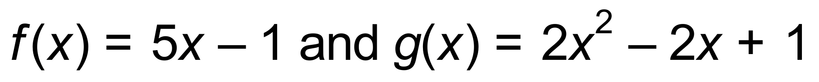

1.  _______________
2. 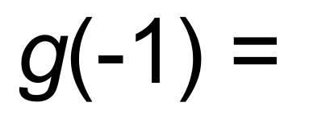 _______________
3. 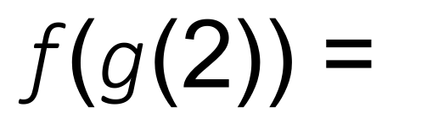 _______________
4. 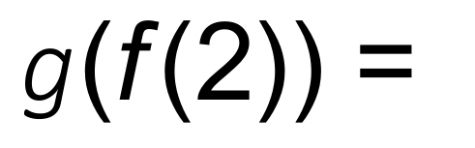 _______________
5. 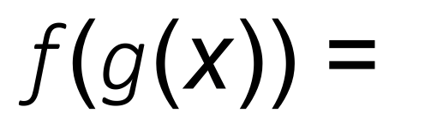 _______________

1.  